# **Project Name: VR Career Exploration Simulator**

## **Project Advisor:** Sir Shahbaz Qadeer

## **Submitted By:** Feroz Mahmood S2023266095

## **Section:** V20

## **Course:** Software Engineering

## **Session:** F2025

## **University Name:** University of Management and Technology

## **Dedication**

This project is dedicated to our families, friends, and mentors, whose unwavering support and encouragement have guided us throughout this journey. Their belief in our vision and continuous motivation have been instrumental in bringing this project to life. We also extend our gratitude to our academic advisors and peers for their invaluable insights and feedback.

## **Acknowledgment**

I would like to express my deepest gratitude to my project advisor, Sir Shahbaz Qadeer, for his invaluable guidance, support, and encouragement throughout this project. His expertise and insights have been instrumental in shaping this work.

I am also grateful to my family and friends for their unwavering support and motivation. Their belief in my abilities has kept me determined and focused.

A special thanks to my peers and colleagues who provided constructive feedback and shared their knowledge, making this journey a collaborative and enriching experience.

## **Project Title: VR Career Exploration Simulator**

### **Objective:**

The objective of this project is to create an immersive virtual reality platform that enables students and professionals to explore different career paths through interactive simulations.

### **Undertaken by:**

Feroz Mahmood ID S2023266095

### **Supervised by:**

Sir Shahbaz Qadeer

### **Starting Date:** 4th Feb 2025

### **Completion Date:** 5th Feb 2025

- **Designing Tools:** EdrawMax, Miro, Venngage

* **VR Hardware Compatibility:** Oculus, HTC Vive, Windows Mixed Reality
* **Database:** Firebase / MySQL

## **Abstract**

The VR Career Exploration Simulator is an immersive platform that enables users to experience different professions in a virtual environment. It allows students and job seekers to explore career paths, perform job-specific tasks, and receive real-time feedback, bridging the gap between career aspirations and practical experience.

## **Table of Contents**

1. Introduction
   1. 1.1 Motivation
   2. 1.2 Project Overview
   3. 1.3 Problem Statement
   4. 1.4 Objectives
2. Domain Analysis
   1. 2.1 Target Users
   2. 2.2 Stakeholders
   3. 2.3 Social & Economic Impact
3. Requirements Analysis
   1. 3.1 Functional & Non-Functional Requirements
   2. 3.2 List of Actors
   3. 3.3 Use Cases
   4. 3.4 System Use Case
   5. 3.5 Extended Use Cases
4. Data Flow Diagram (Optional)
   1. 4.1 Level 0 DFD (**Placeholder for Diagram**)
   2. 4.2 Level 1 DFD (**Placeholder for Diagram**)
   3. 4.3 Level 2 DFD (**Placeholder for Diagram**)
5. System Design
   1. 5.1 System Architecture (**Placeholder for Diagram**)
   2. 5.2 Class Diagram (**Placeholder for Diagram**)
   3. 5.3 Sequence Diagrams (**Placeholder for Diagram**)
   4. 5.4 Collaboration Diagrams (**Placeholder for Diagram**)
   5. 5.5 ERD (**Placeholder for Diagram**)
   6. 5.6 Data Dictionary
6. Implementation Details
   1. 6.1 Development Setup
   2. 6.2 Algorithms
   3. 6.3 Constraints
   4. 7.1 Extended Test Cases
7. Conclusion
8. Future Work
9. References
10. Appendix

## **1. Introduction**

### **1.1 Motivation**

Virtual Reality (VR) has transformed education and training by providing immersive learning experiences. Many students struggle to find the right career path due to a lack of real-world exposure. The VR Career Exploration Simulator helps bridge this gap by providing a hands-on virtual job shadowing experience.

### **1.2 Project Overview**

This project aims to create a VR-based career exploration tool where users can select professions, engage in real-world simulations, and receive feedback to guide their career choices.

### **1.3 Problem Statement**

Students and job seekers often lack direct exposure to professional environments before making career decisions. This leads to uncertainty and potential career mismatches. Our VR simulator provides hands-on career experiences, reducing career confusion.

### **1.4 Objectives**

* Develop an immersive VR experience for career exploration.
* Provide interactive skill-building mini-games.
* Deliver real-time AI-driven feedback.
* Enable mentor interaction for personalized career guidance.
* Track user progress and generate analytics.

## **2. Domain Analysis**

### **2.1 Target Users**

* Students exploring career options.
* Job seekers preparing for new roles.
* Career counselors and educators.

### **2.2 Stakeholders**

* Universities & Schools
* Career Counselors
* Employers & Industry Experts

### **2.3 Social & Economic Impact**

* Helps students make informed career choices.
* Reduces career mismatches and dropouts.
* Enhances workforce readiness.

## **3. Requirements Analysis**

### **3.1 Functional & Non-Functional Requirements**

* Users should be able to select and experience different career paths.
* AI should provide real-time feedback based on user actions.
* The system should track user progress and offer career suggestions.
* The software should be compatible with major VR devices.

### **3.2 List of Actors**

* **User**: Interacts with the simulator.
* **AI Feedback System**: Evaluates user performance.
* **Mentor**: Provides career guidance.
* **Administrator**: Manages system configurations.

### **3.3 Use Cases**

* Register & Login
* Select Career Path
* Perform Job Tasks
* Receive AI Feedback
* Connect with a Mentor
* Track Career Progress

### **3.4 System Use Case**

The system use case describes the key interactions between users and the VR Career Exploration Simulator. It outlines how different actors, such as students, mentors, and administrators, interact with various system components to achieve their objectives.

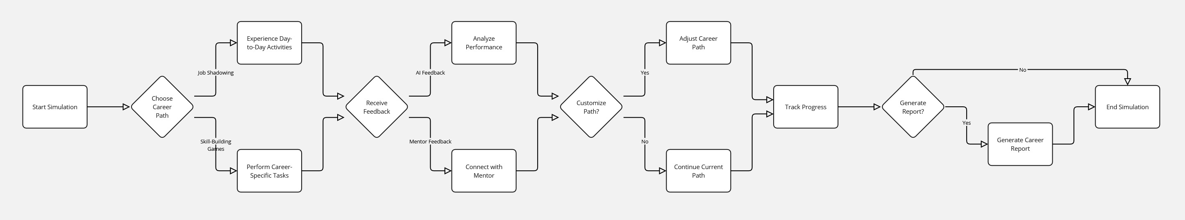

### **3.5 Extended Use Cases**

1. **User Registration & Login**
   1. The user creates an account and logs into the system.
   2. The system verifies credentials and grants access to the platform.

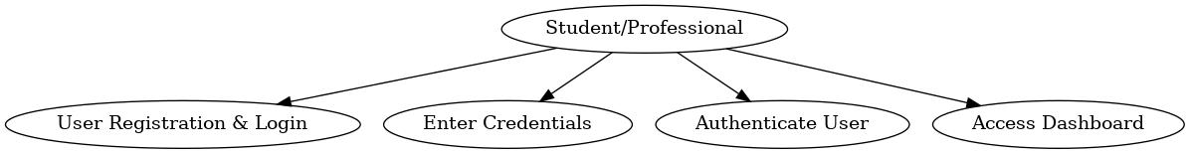

1. **Career Path Selection**
   1. The user browses and selects a career path from available options.
   2. The system loads career-specific simulations based on selection.

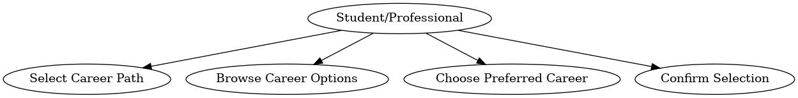

1. **Entering VR Simulation**
   1. The user enters an immersive VR environment to explore a chosen career.
   2. The system initializes the VR workspace with career-related scenarios.

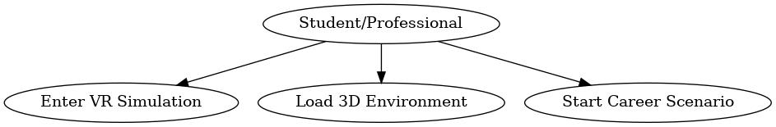

1. **Performing Job-Specific Tasks**
   1. The user completes assigned tasks related to the selected career.
   2. The system evaluates performance and provides real-time guidance.

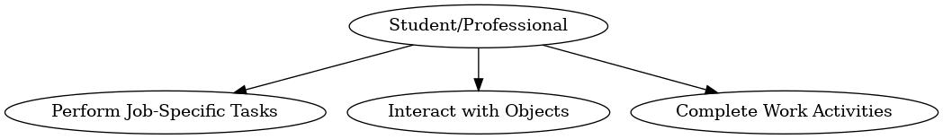

1. **Playing Skill-Building Mini-Games**
   1. The user participates in mini-games designed to enhance career-related skills.
   2. The system tracks progress and assigns skill-based scores.

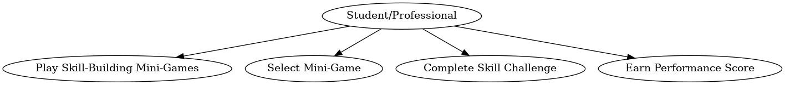

1. **Receiving AI-Driven Feedback**
   1. The system analyzes user performance and provides AI-generated feedback.
   2. Users receive recommendations for improvement based on results.

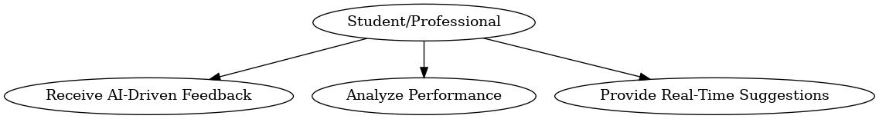

1. **Connecting with a Mentor**
   1. The user requests career guidance from a mentor.
   2. The system schedules sessions and facilitates mentor-user interaction.

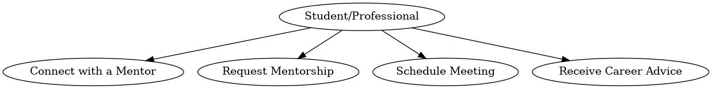

1. **Tracking Career Progress & Analytics**
   1. The user reviews performance metrics and career analytics.
   2. The system generates reports based on the user’s journey.

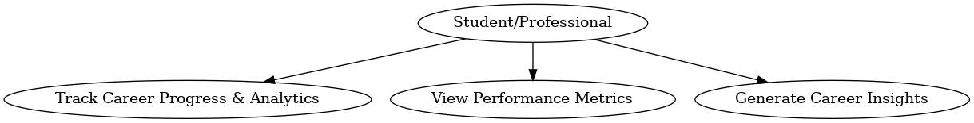

1. **Saving & Resuming Career Simulations**
   1. The user can save progress and resume career simulations later.
   2. The system ensures session continuity and data retention.

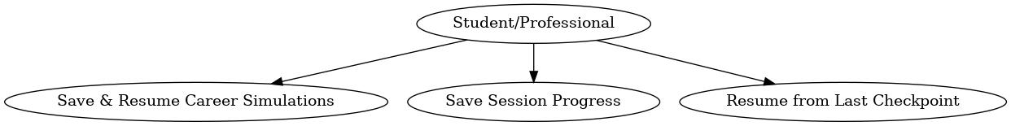

1. **Cross-Platform Compatibility & Accessibility**
2. The system adapts content for VR and non-VR devices.
3. Users can access the platform on multiple devices, ensuring inclusivity and flexibility.

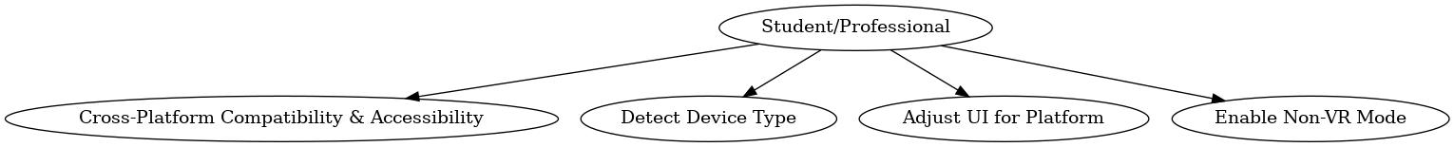

## **4. Data Flow Diagram (DFD)**

* **Level 0 DFD:**

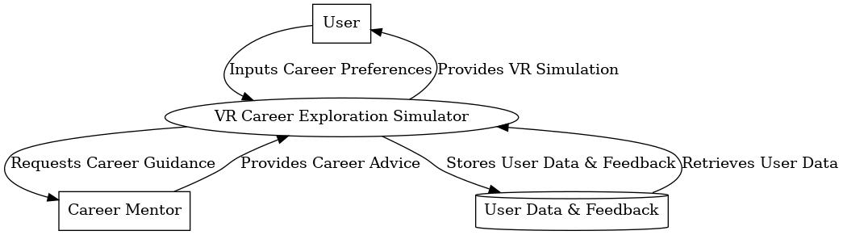

* **Level 1 DFD:**

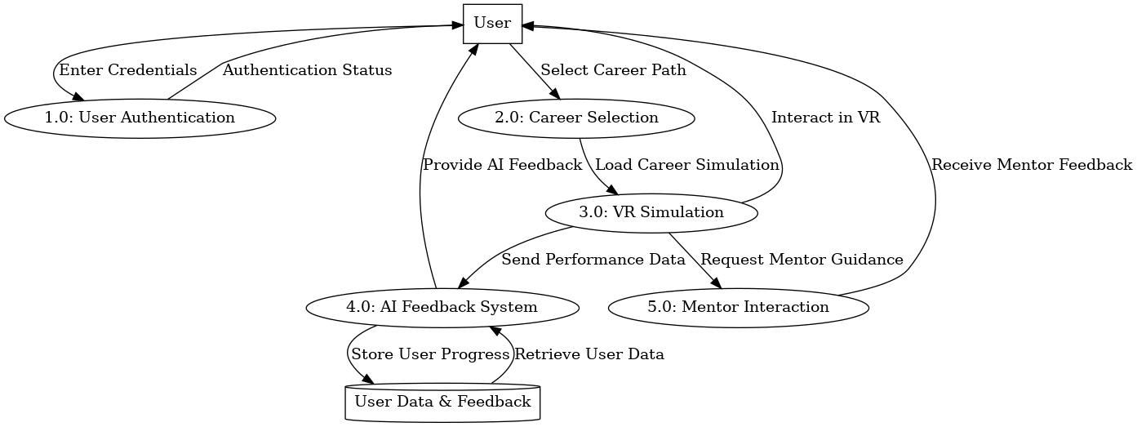

* **Level 2 DFD:**

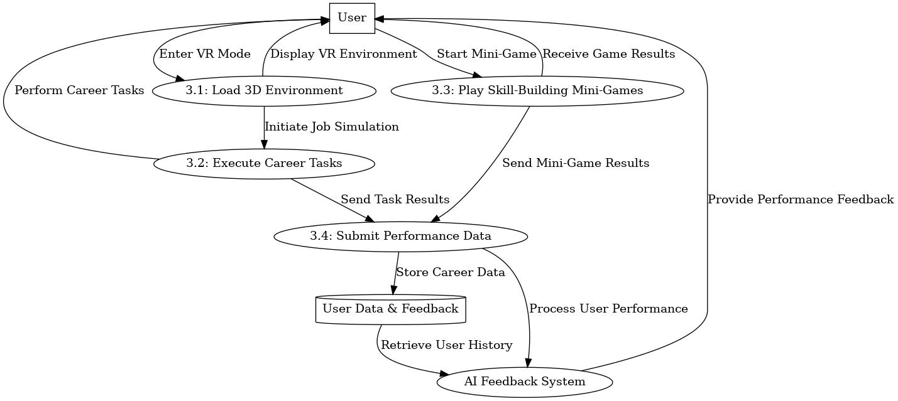

## **5. System Design**

### **5.1 ERD Diagram of System**

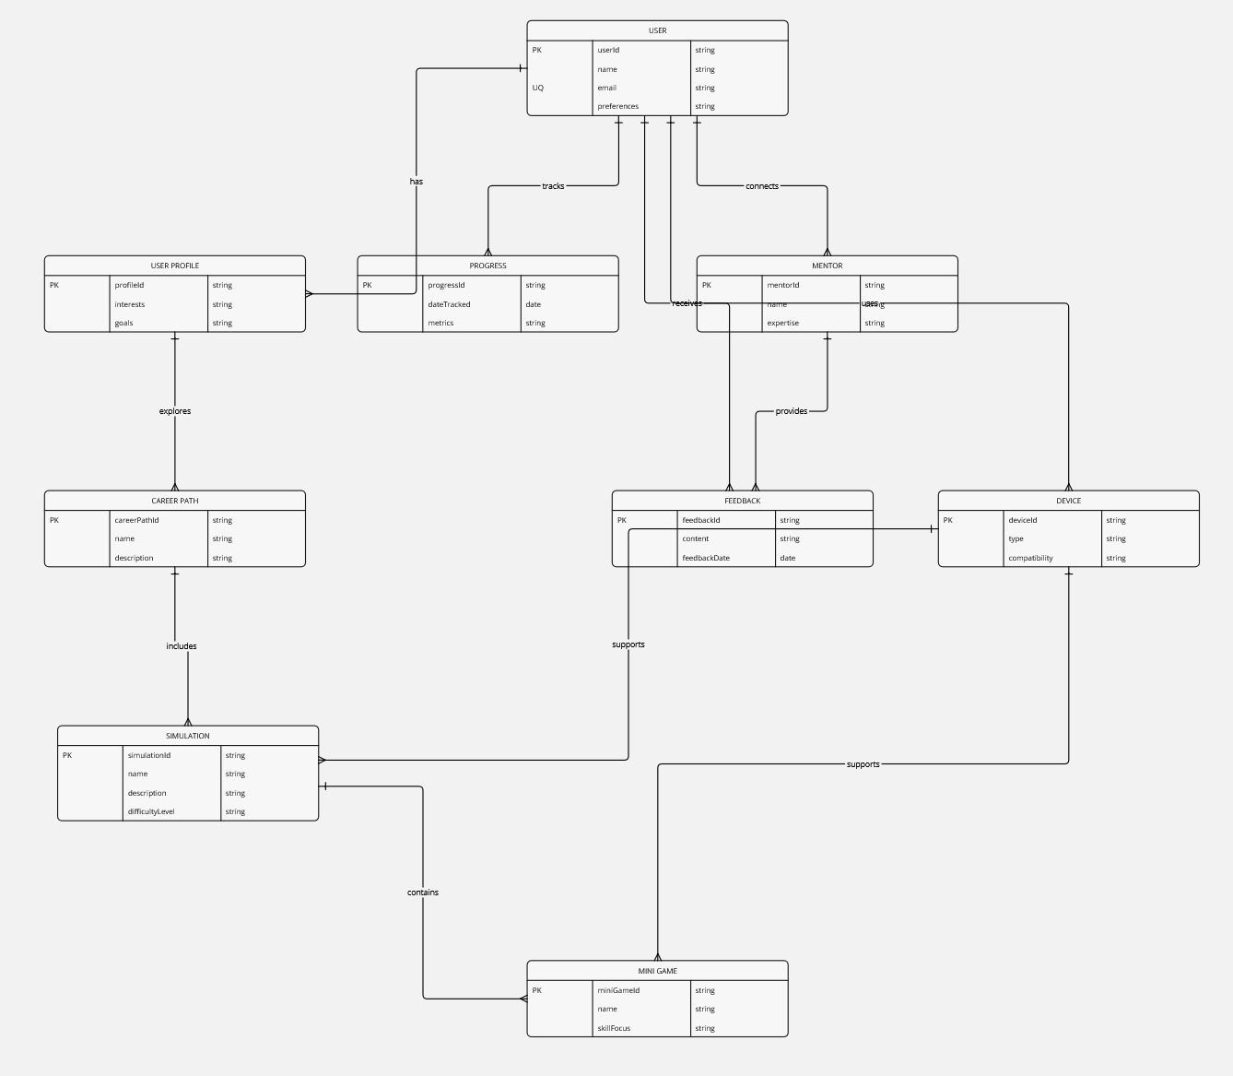

### **5.2 Class Diagram**

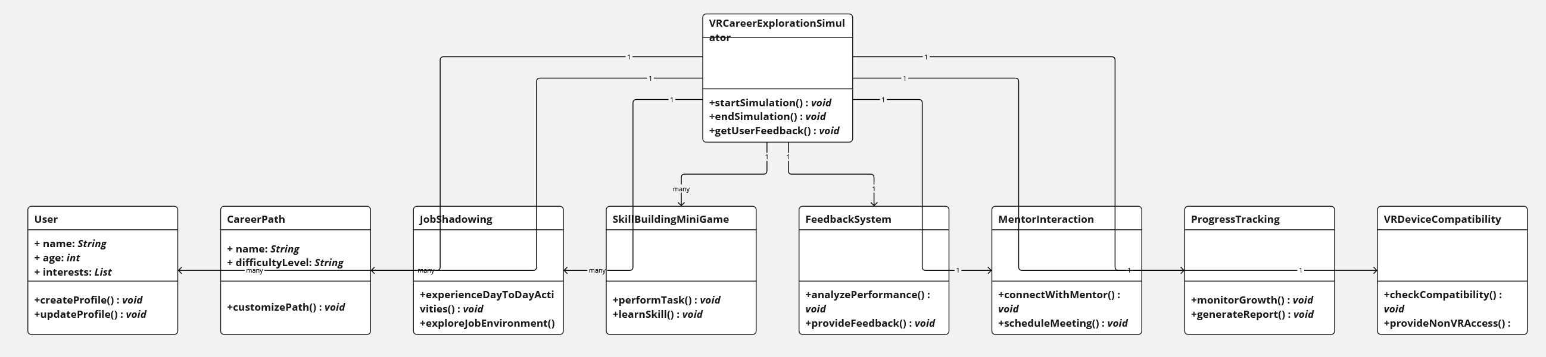

### **5.3 Sequence Diagram**

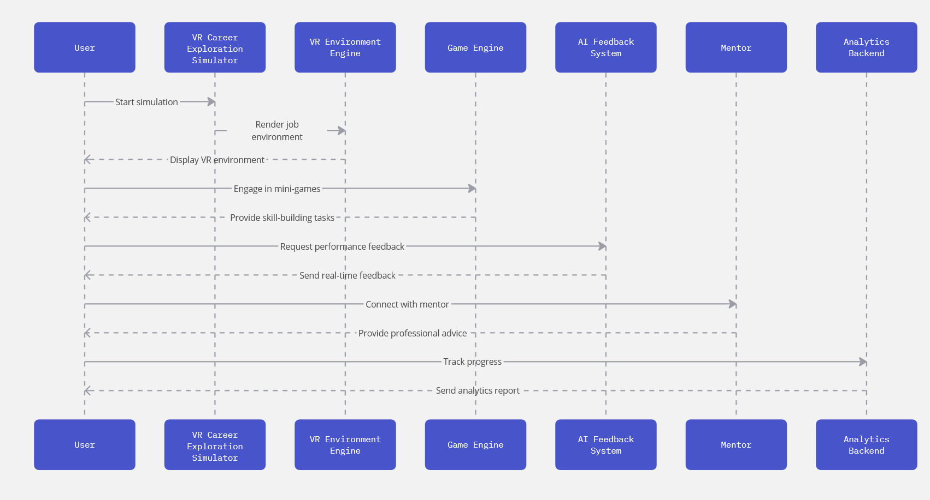

### **5.4 State Diagram**

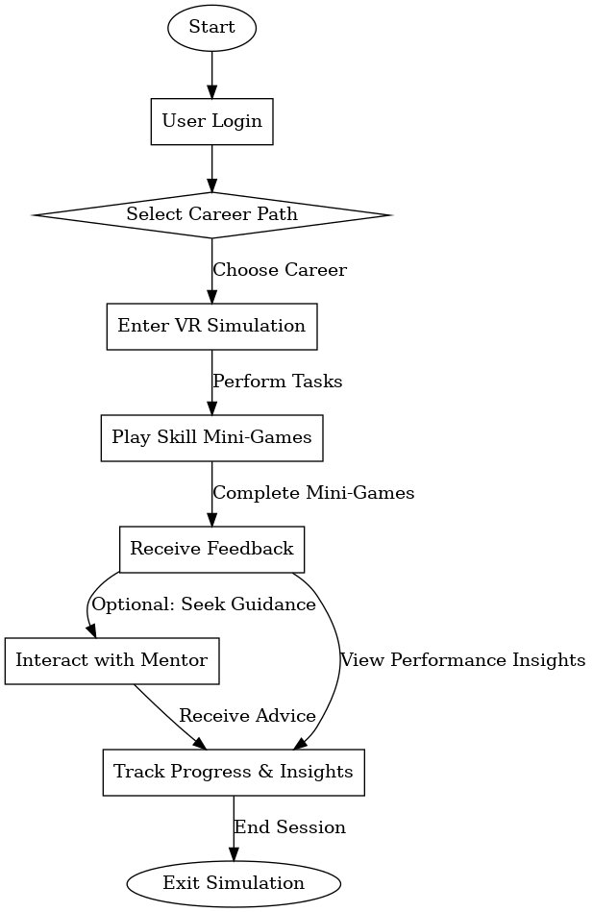

### **5.5 Activity Diagram**

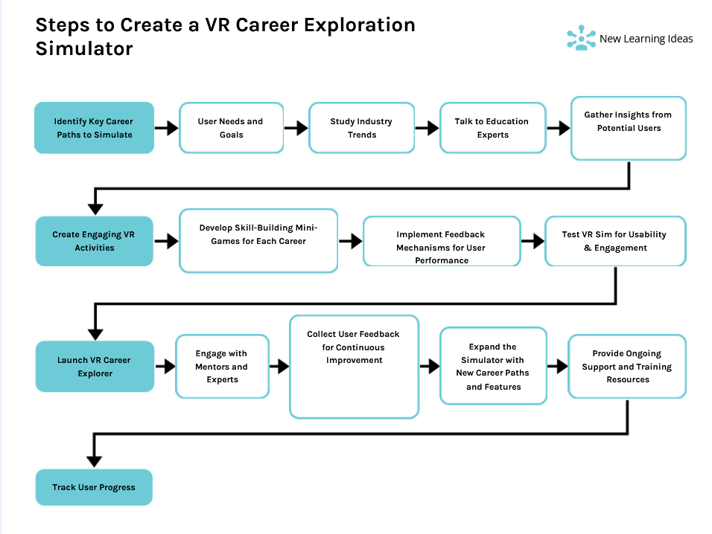

### **5.6 Gantt Chart**

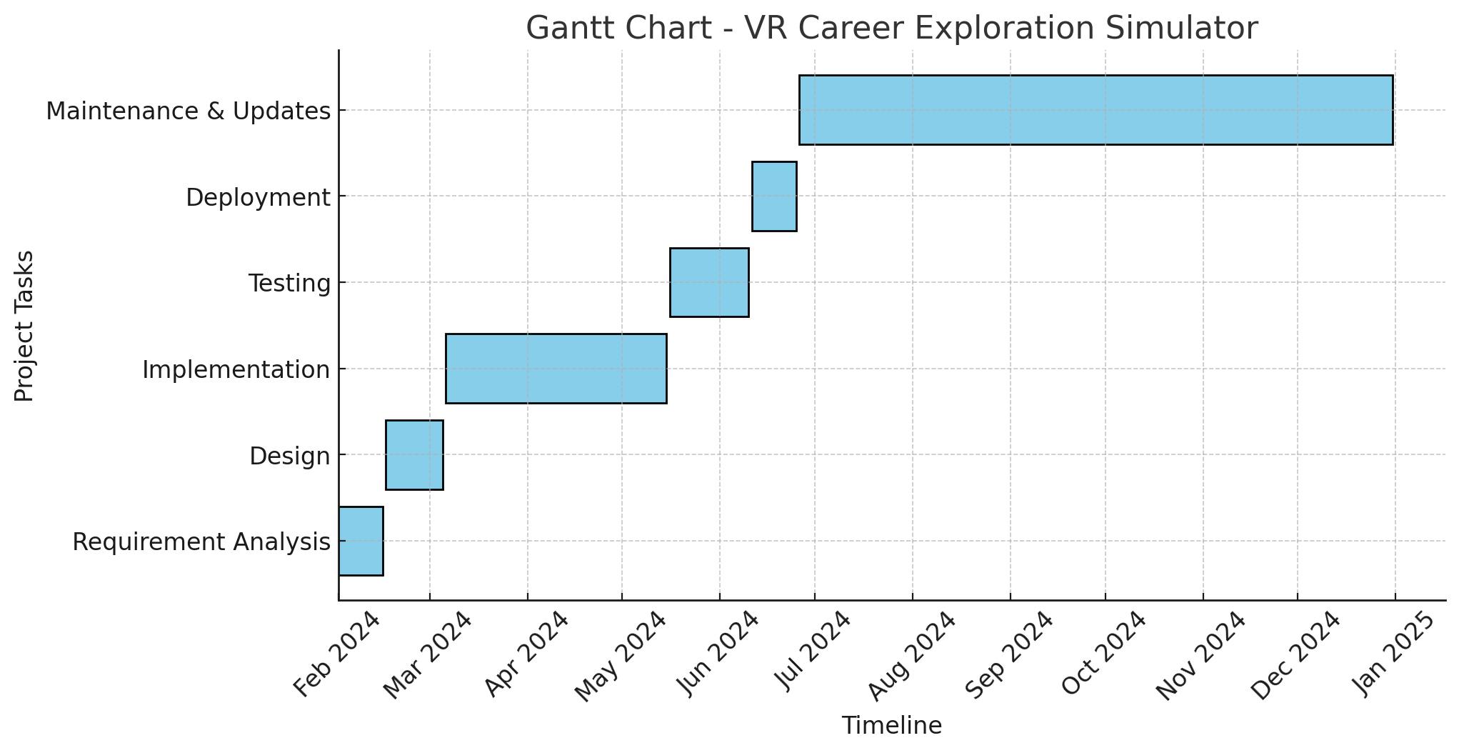

## **6. Implementation Details**

* Development tools and technologies used.
* Algorithm for AI feedback.
* System constraints and limitations.

## **9. Conclusion**

The VR Career Exploration Simulator has been developed to provide an immersive and interactive experience for students and professionals seeking career guidance. By simulating real-world job environments, users gain practical insights into different professions, reducing career uncertainty and improving decision-making.

This project successfully integrates VR technology with AI-driven feedback, mentor interaction, and progress tracking. The system ensures an engaging user experience while offering valuable career-related insights. The development process has demonstrated the potential of VR in education and career exploration, paving the way for future advancements in virtual training.

Overall, this project highlights the effectiveness of immersive learning and stands as a step toward bridging the gap between career aspirations and practical experience.

## **10. Future Work**

The VR Career Exploration Simulator has significant potential for future enhancements and scalability. Some of the key areas for improvement include:

* **Expansion of Career Paths:** Adding more professions and industries to provide a wider range of career exploration opportunities.
* **AI-Powered Career Recommendations:** Implementing machine learning algorithms to analyze user interactions and suggest personalized career paths.
* **Multi-User Collaboration:** Introducing multiplayer functionality where users can interact and collaborate in shared virtual workplaces.
* **Integration with Real-World Data:** Connecting with industry databases to provide real-time job market insights and trends.
* **Enhanced Mentor Interaction:** Improving mentor sessions with AI-powered chatbots and virtual career advisors.
* **Cross-Platform Accessibility:** Expanding support for more VR and non-VR platforms, including mobile devices and web browsers.
* **Gamification Features:** Incorporating badges, leaderboards, and rewards to enhance user engagement and motivation.
* **Internship & Job Matching:** Partnering with companies to provide internship and job placement opportunities based on user performance and interests.
* **Augmented Reality (AR) Integration:** Exploring the use of AR for hybrid career exploration experiences.

By focusing on these areas, the VR Career Exploration Simulator can continue to evolve into a comprehensive career development tool, providing even greater value to students and job seekers worldwide.

## **11. References**

1. Burdea, G., & Coiffet, P. (2003). *Virtual Reality Technology*. Wiley-IEEE Press.
2. Sherman, W. R., & Craig, A. B. (2018). *Understanding Virtual Reality: Interface, Application, and Design*. Morgan Kaufmann.
3. Dede, C. (2009). *Immersive Interfaces for Engagement and Learning*. Science, 323(5910), 66-69.
4. Slater, M., & Sanchez-Vives, M. V. (2016). *Enhancing Our Lives with Immersive Virtual Reality*. Frontiers in Robotics and AI, 3, 74.
5. Pantelidis, V. S. (2010). *Reasons to Use Virtual Reality in Education and Training: A Bibliographic Essay*. Themes in Science and Technology Education, 2(1-2), 59-70.
6. Zhang, X., & Zhang, Y. (2021). *A Review of Virtual Reality Applications in Career Education and Training*. Journal of Educational Technology & Society, 24(3), 25-37.
7. IEEE Xplore Digital Library. (2024). *Recent Advances in Virtual Reality for Career Development*. Retrieved from [https://ieeexplore.ieee.org](https://ieeexplore.ieee.org/)
8. Google Scholar. (2024). *Studies on VR-Based Career Simulation*. Retrieved from [https://scholar.google.com](https://scholar.google.com/)

## **12. Appendix**

This appendix contains additional supporting information related to the VR Career Exploration Simulator project. It may include:

* Sample user interaction flows and screenshots.
* Detailed test case scenarios (if applicable).
* Extended system architecture details.
* Any additional resources referenced during development.